**The Battle of Neighborhoods - The Best Place for Cafe in Toronto**



**Introduction**

A contractor is looking to open a Cafe in Toronto, one of the most densely populated areas in Canada. He has contacted me for advice on the suitable neighborhoods to open the Cafe. In this case, we will utilize data science skills and the tools to use location data to explore Toronto neighborhoods, to help my contractor, and any other business owners who might be interested in starting their business in Toronto.

**Data Section**

In this project, we will need the following data to solve this problem and execute our idea:

1. Wikipedia page of Toronto neighborhoods

The following Wikipedia page has all the information we need to explore and cluster the neighborhoods in Toronto. We will scrape the Wikipedia page and wrangle the data, clean it, and then read it into a pandas data frame of the postal code of each neighborhood along with the borough name and neighborhood name.

<https://en.wikipedia.org/wiki/List_of_postal_codes_of_Canada:_M>

1. Geospatial Coordinates csv file

We will use the following link to the Geospatial_Coordinates csv file to get the latitude and the longitude coordinates of each neighborhood.

<http://cocl.us/Geospatial_data>

1. Foursquare API

We will need to use the Foursquare location data, and download all venues from all neighborhoods in Toronto.

<https://api.foursquare.com>

**Methodology Section**

1. K-Means Clustering

In this project, we will use K-Means Clustering algorithm to cluster the neighborhoods.

1. One Hot Encoding

In this project, we will do one hot encoding for getting dummies of the venue category.

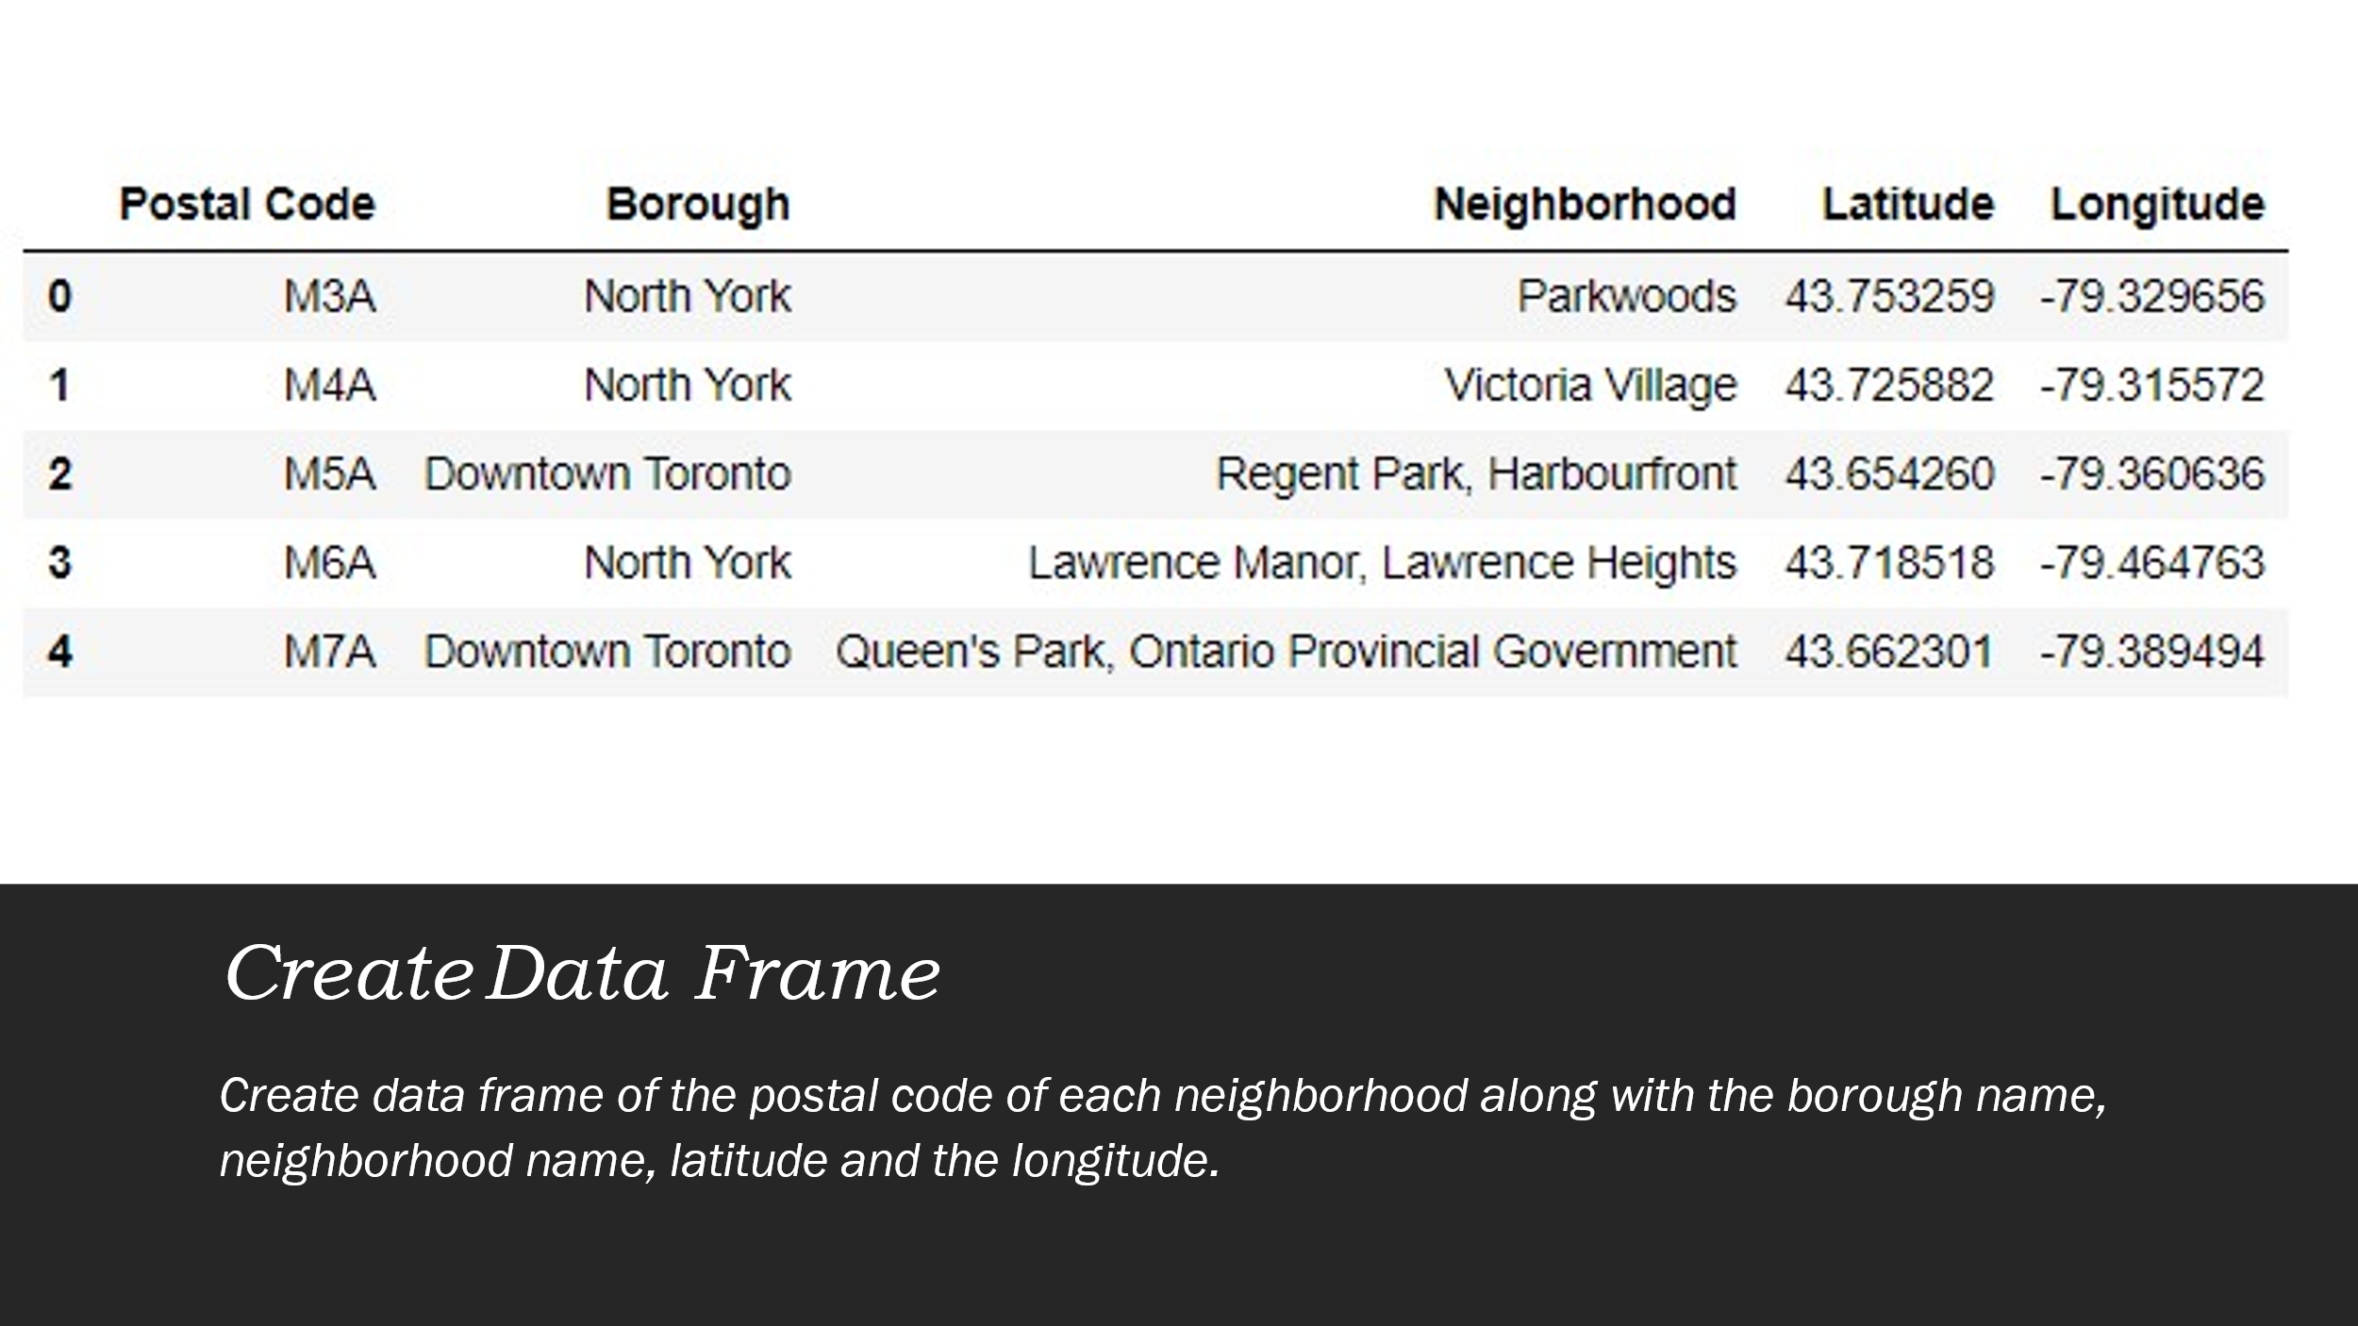

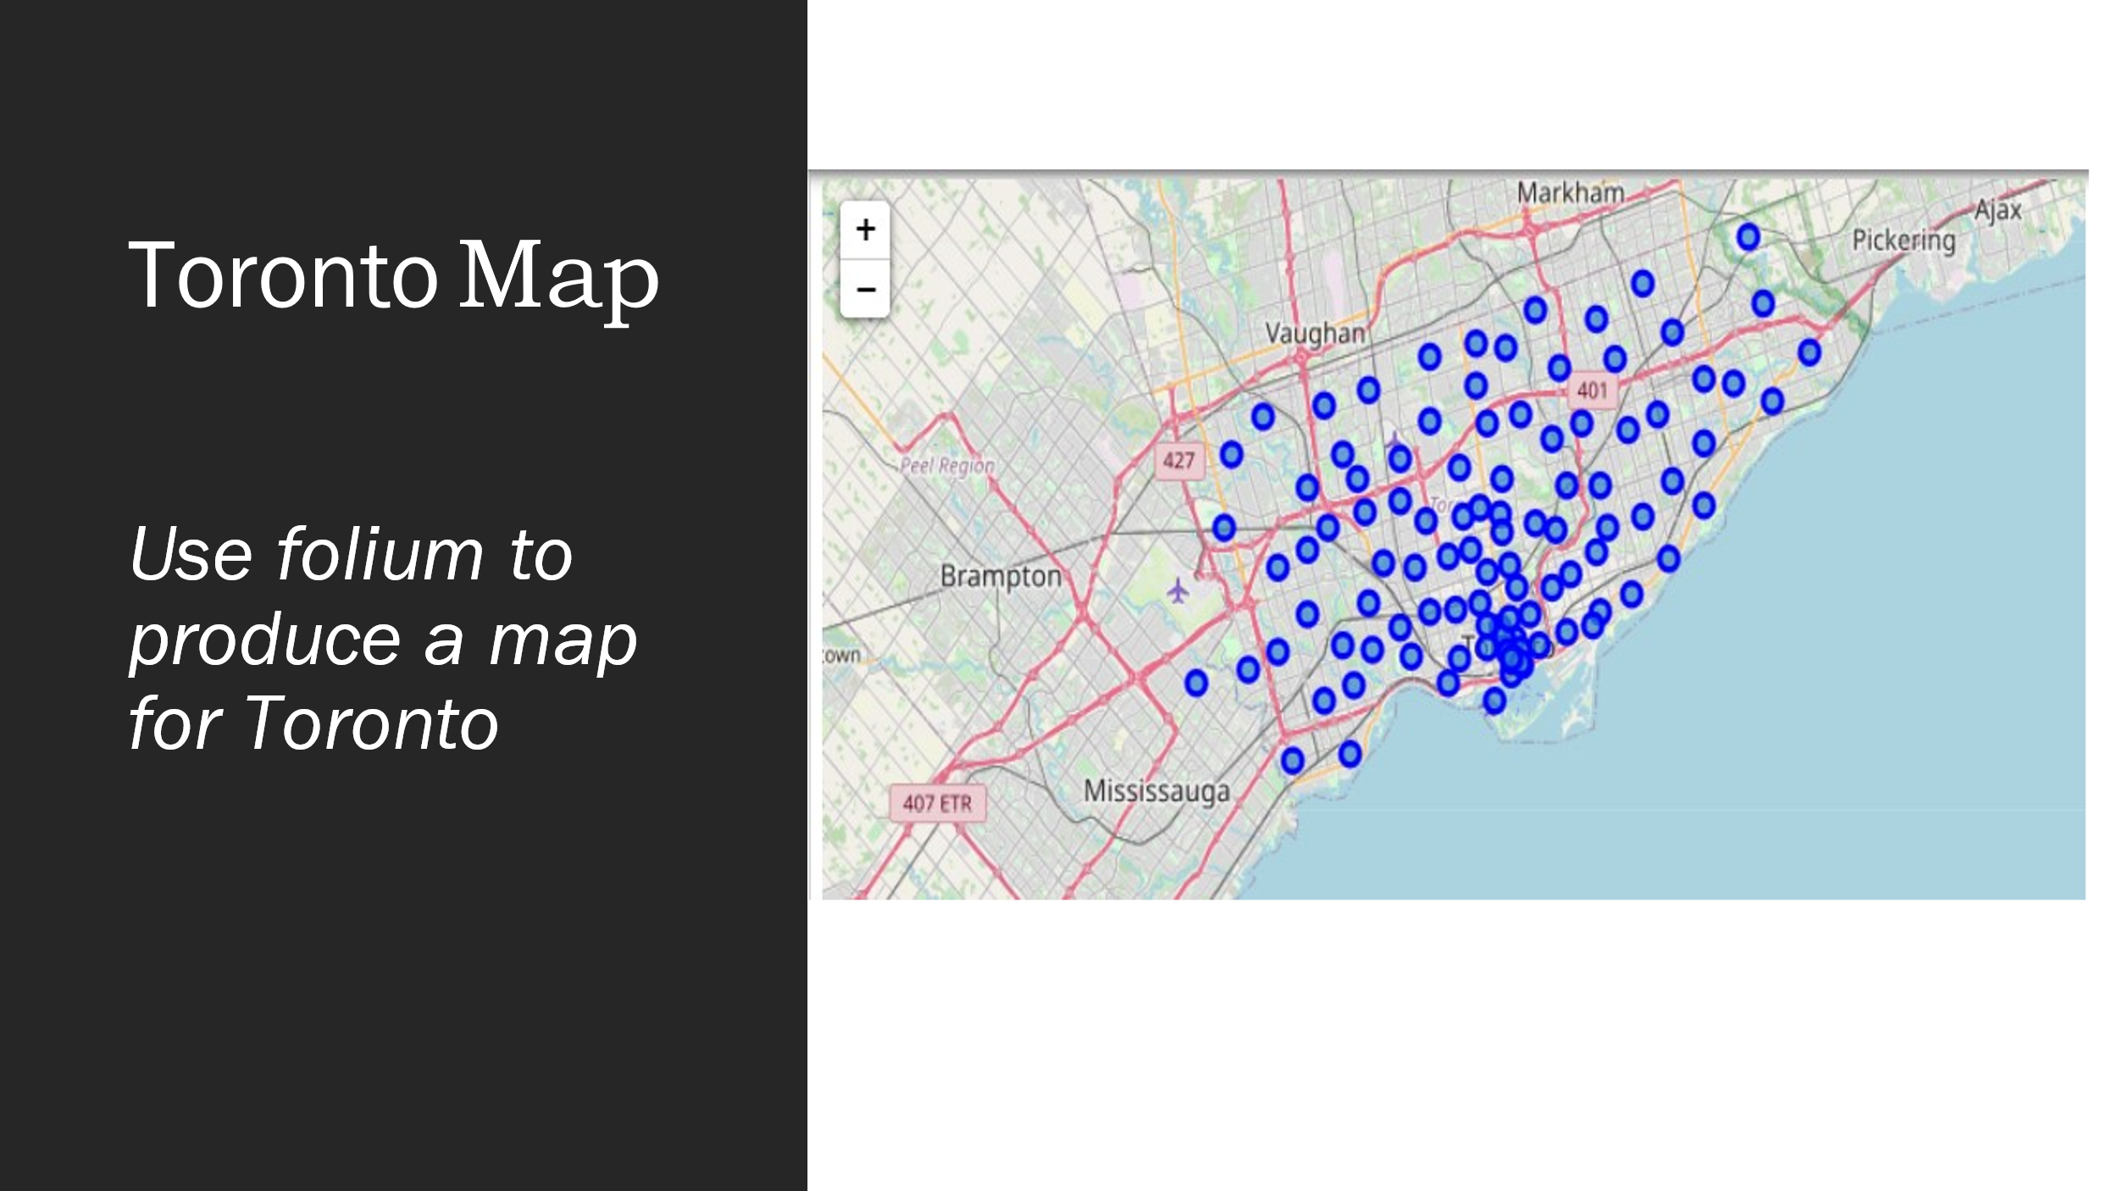

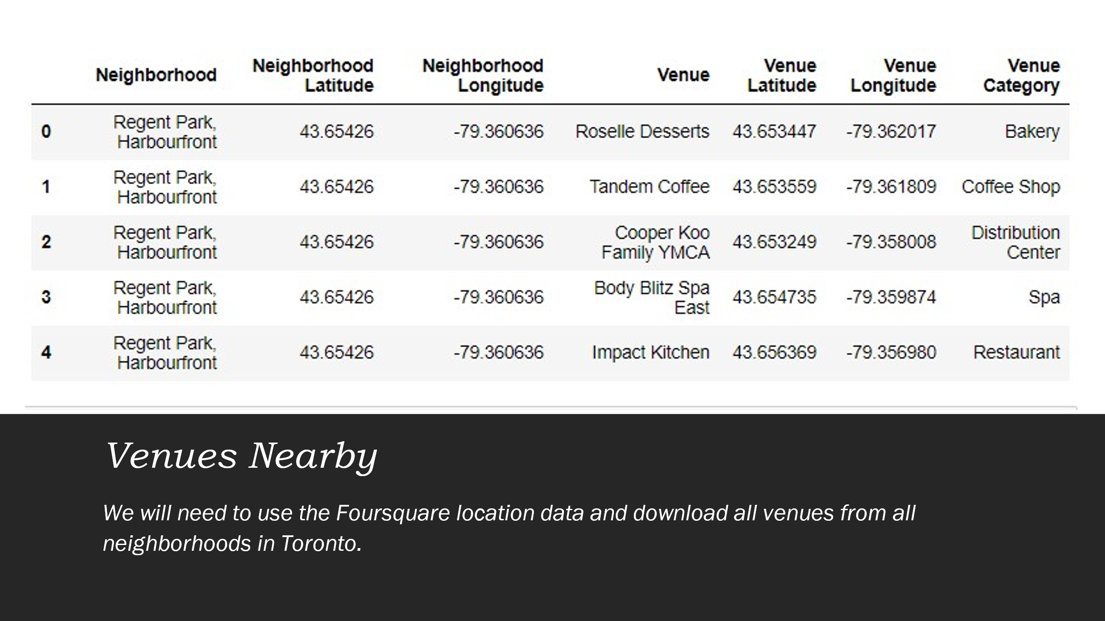

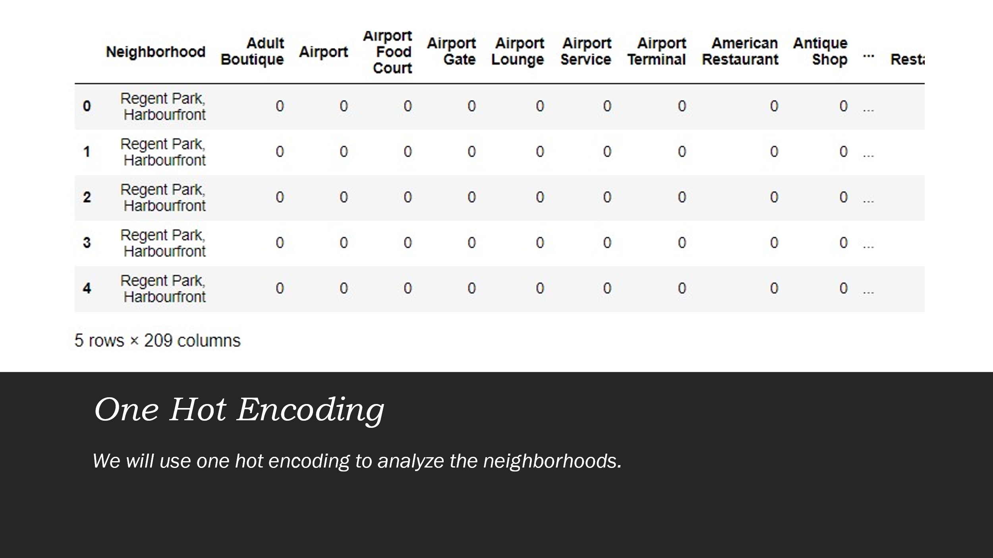

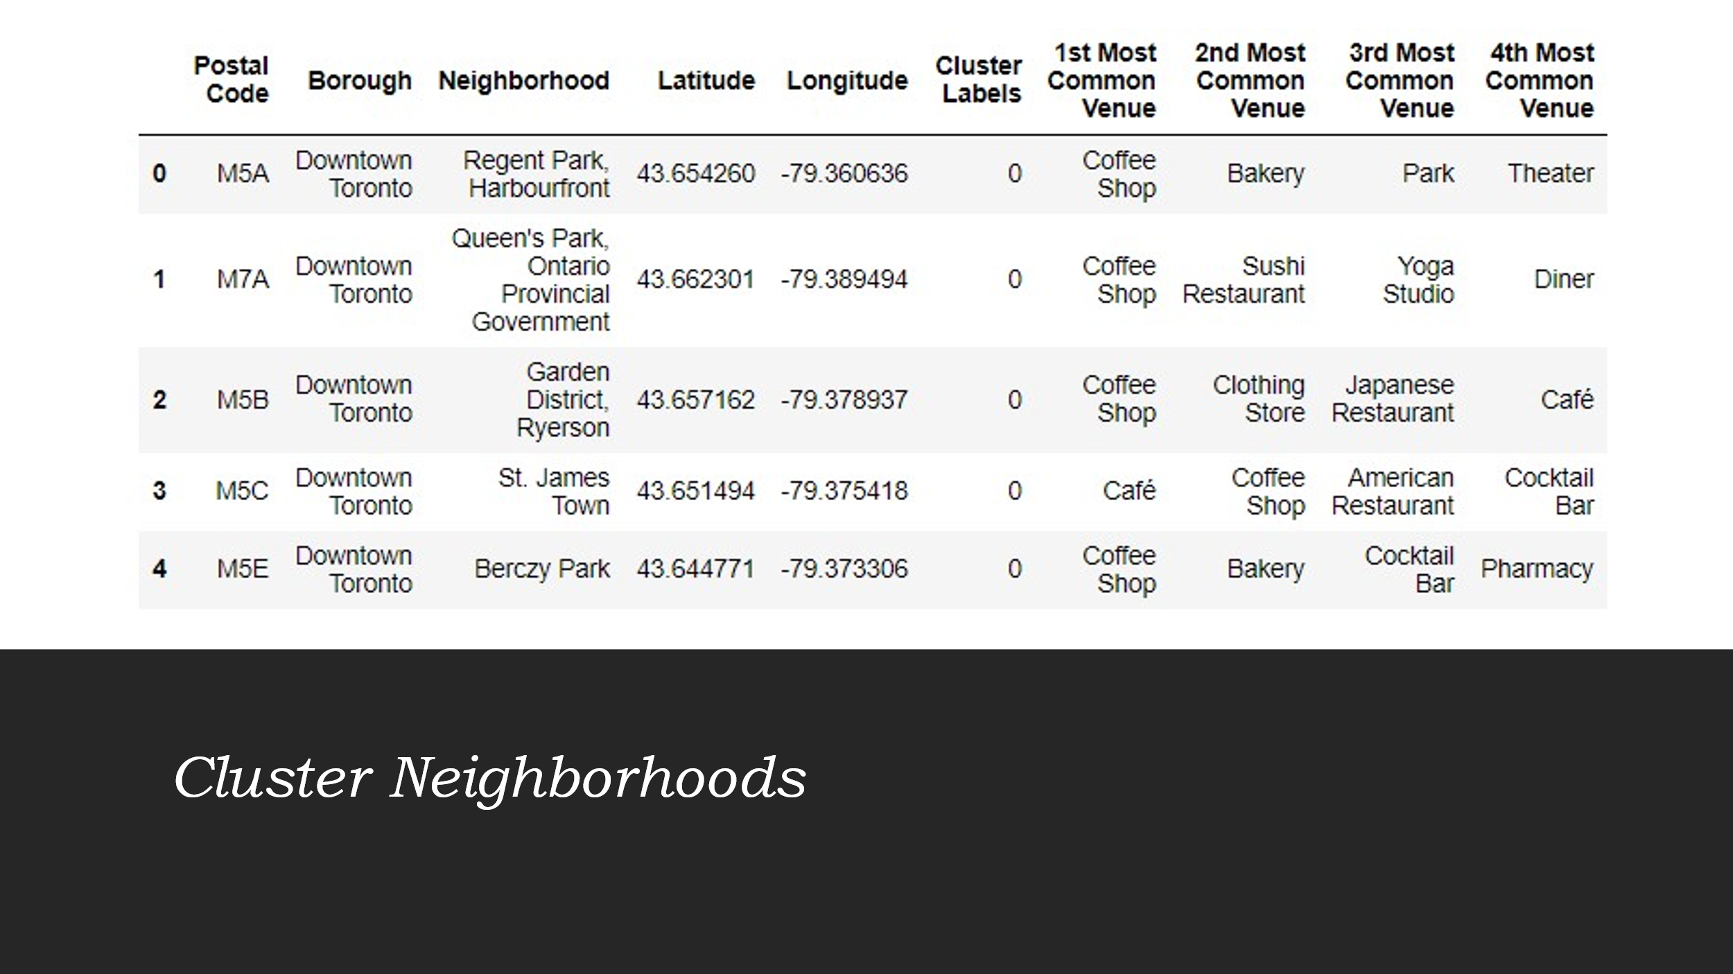

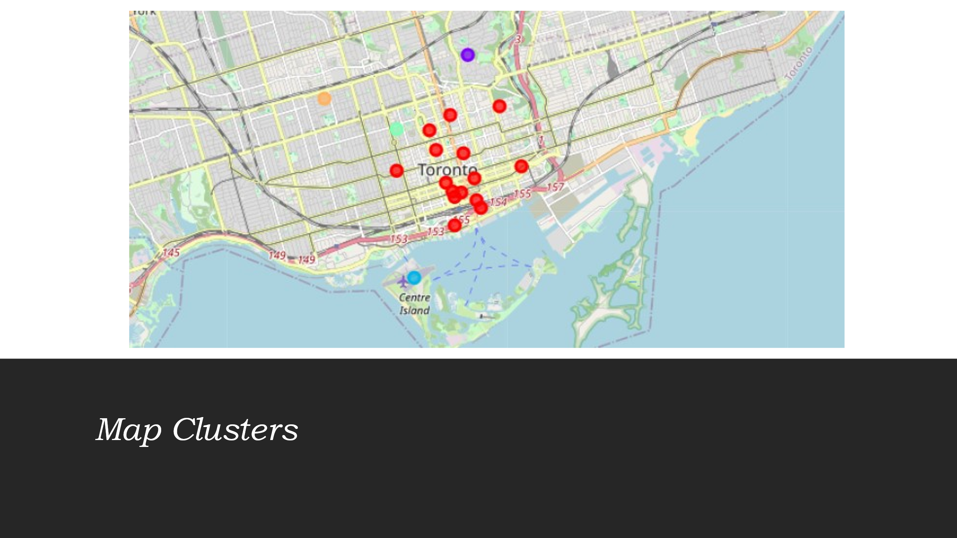

**Discussion Section**

According to the analysis, Rosedale in Cluster 1 will be the best place for my contractor to open his Cafe. As we built our K-Means dataset and list of neighborhoods with their most common venues, we discovered Cluster 1 provides comparatively less competition than Cluster 0, and closer distance to residentials than Cluster 2.

**Conclusion Section**

To conclude this project, we used Python libraries to handle JSON file, plotting graphs, and other exploratory data analysis. in order to help my contractor, and any other business owners who might be interested in starting their business in Toronto to find the best place for an upcoming Cafe.